**<https://imaguru.host/version-test/>**

**1.** **Отключите изображения в браузере.**

Убедитесь, что использование страницы не заблокировано, а изображения со смысловой нагрузкой имеют текстовые подписи (alt, longdesc).

Результат выполнения: скриншот, на котором видны изменения (изображения отключены) + комментарий (проблемы, которые возникли в связи с отключением изображений).

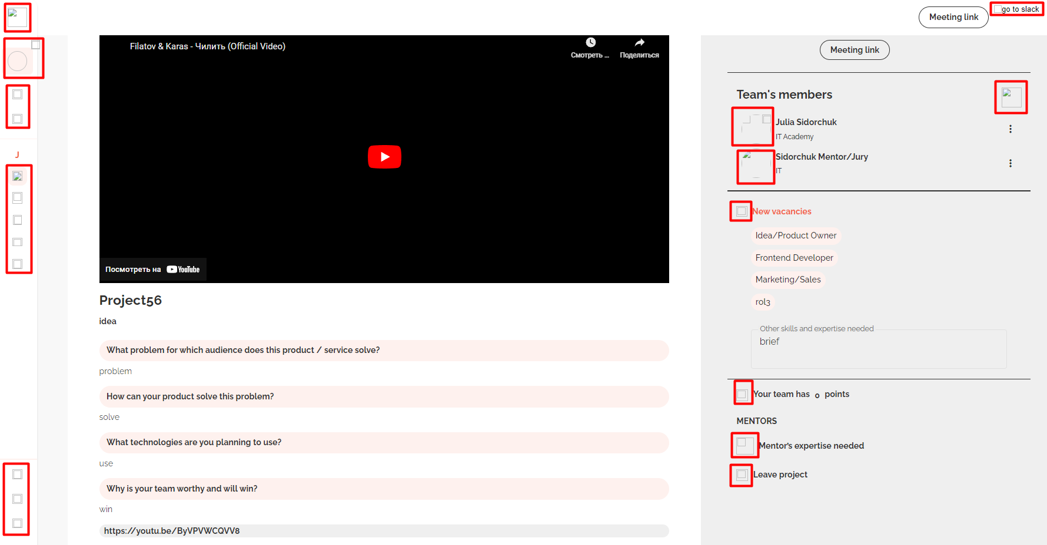

*Conclusion*: The page is not blocked, however the use of the page is quite difficult. Images with a meaning do not have text labels. Functionality of the right sidebar collapsed is impossible if the user don’t remember the location and names of tabs there. It’s impossible to find Chat icon, if the user don’t know its location.

**2.** **Отключите JavaScript в браузере.**

Убедитесь, что данные доступны без поддержки JavaScript.

Результат выполнения: скриншот, на котором видны изменения (JavaScript = off) + комментарий (проблемы, которые возникли в связи с отключением JavaScript).

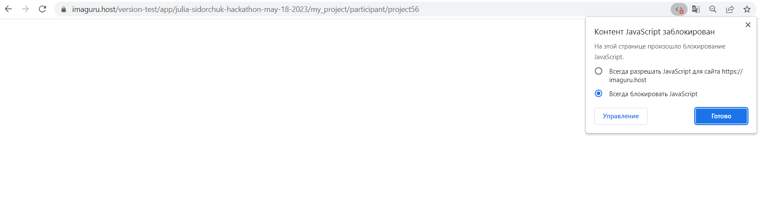

*Conclusion*: Data of the page are not available when JavaScript is switched off. Nothing works. The page is blank.

**3.** **Установите Color Contrast Analyzer или C**olor **BLI**ndness **S**imulator

Используя Color Contrast Analyzer сделайте вывод о возможности использования страницы лицами с проблемами цветовосприятия.

Результат выполнения: скриншоты страницы в различных режимах (Protanopia, Deuteranopia, Tritanopia, Grayscale) + комментарий.

**Color Contrast Analyzer**

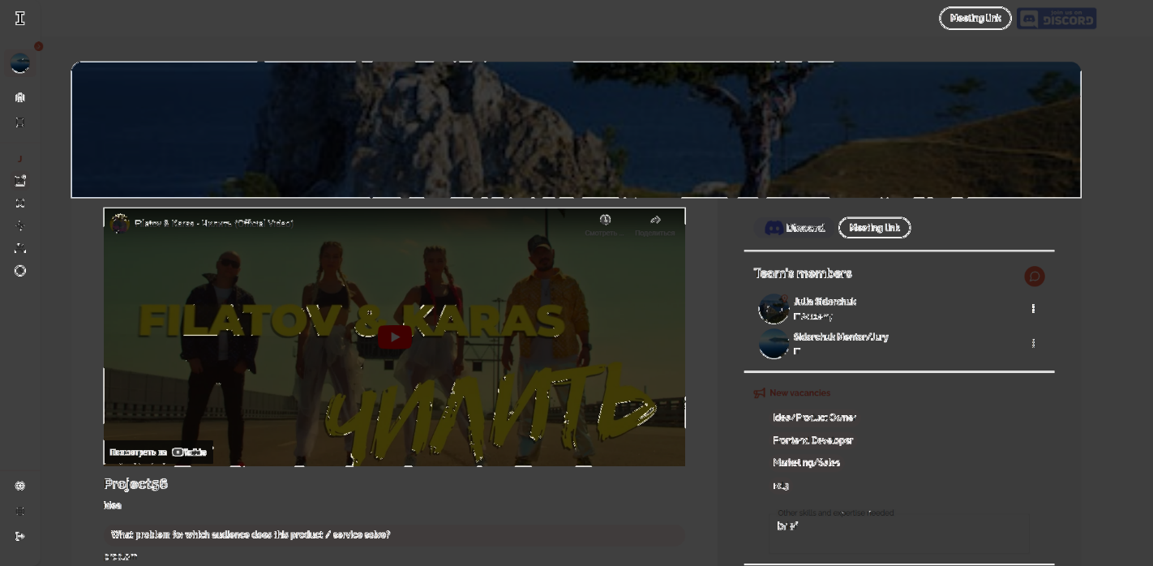

**Color Blindness Simulator**

Protanopia

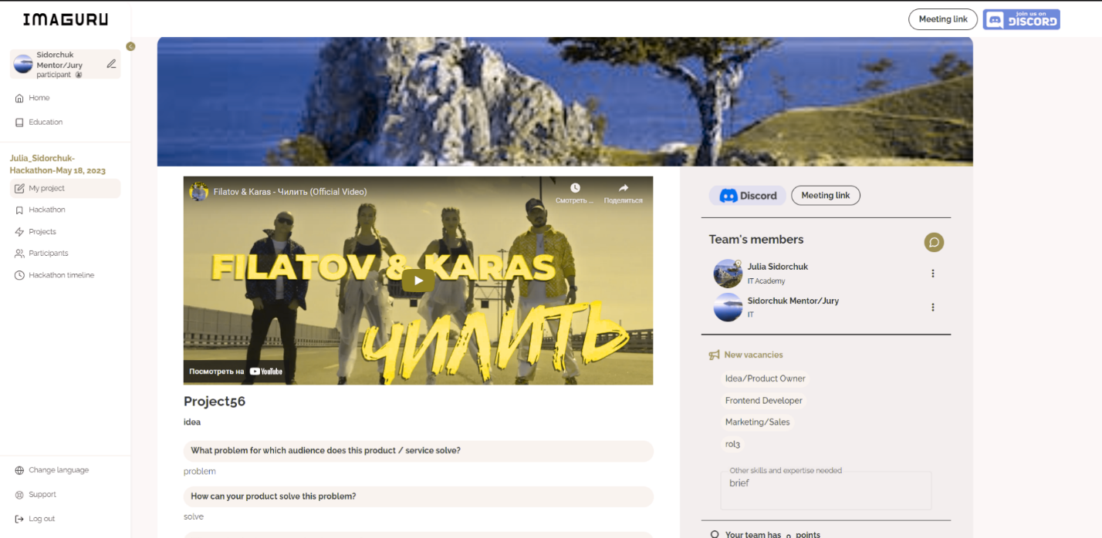

Deuteranopia

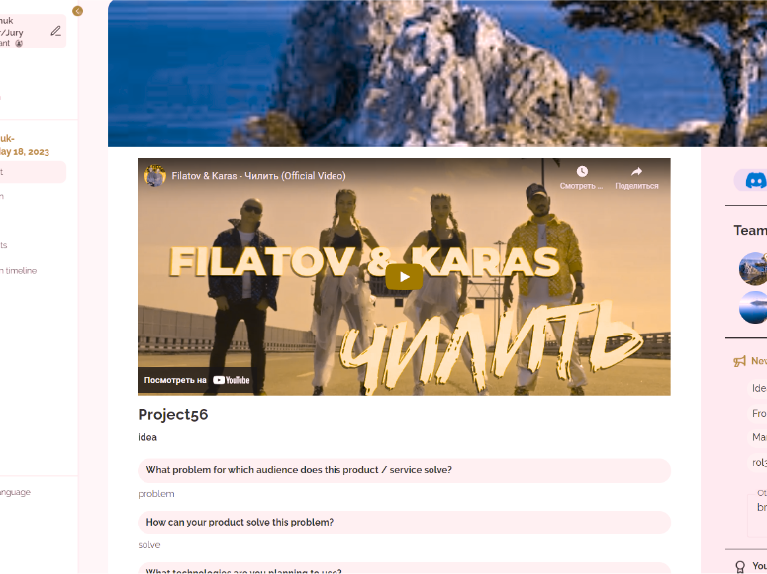

Tritanopia

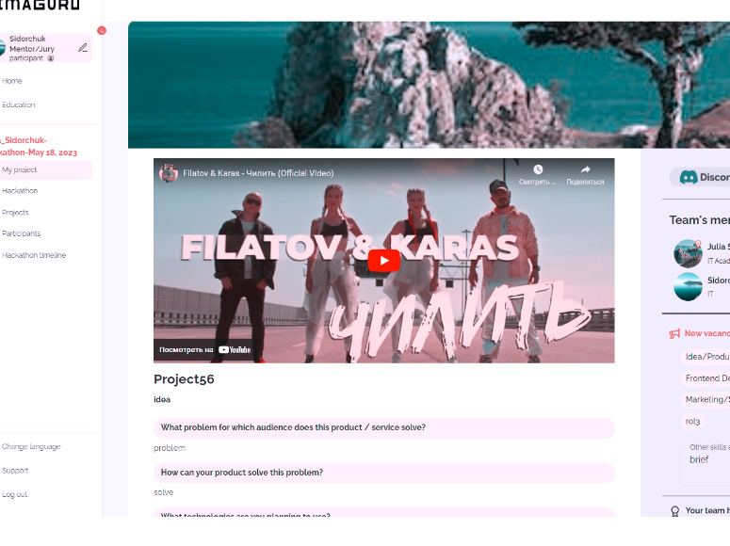

Grayscale

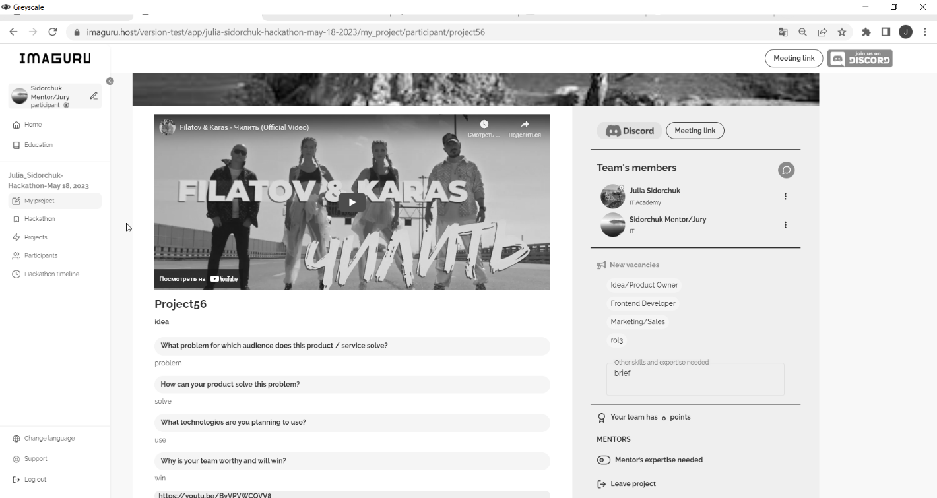

*Conclusion*: It is quite possible for users having problems with visual perception to use functionality of My project page as all the text information is provided at the page.

**4.** **Установите** **WAVE Evaluation Tool.**

Проанализируйте результаты проверки (например): таблицы/ формы/ изображения/ссылки/ etc.

Результат выполнения: 1-2 баг репорта (однотипные проблемы описываются в одном баг репорте).

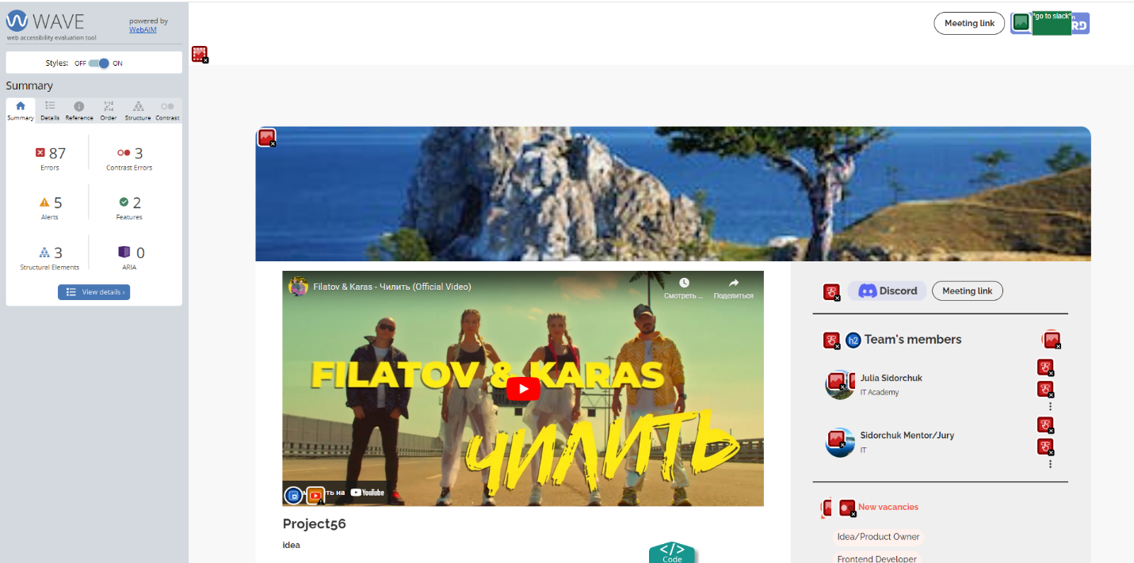

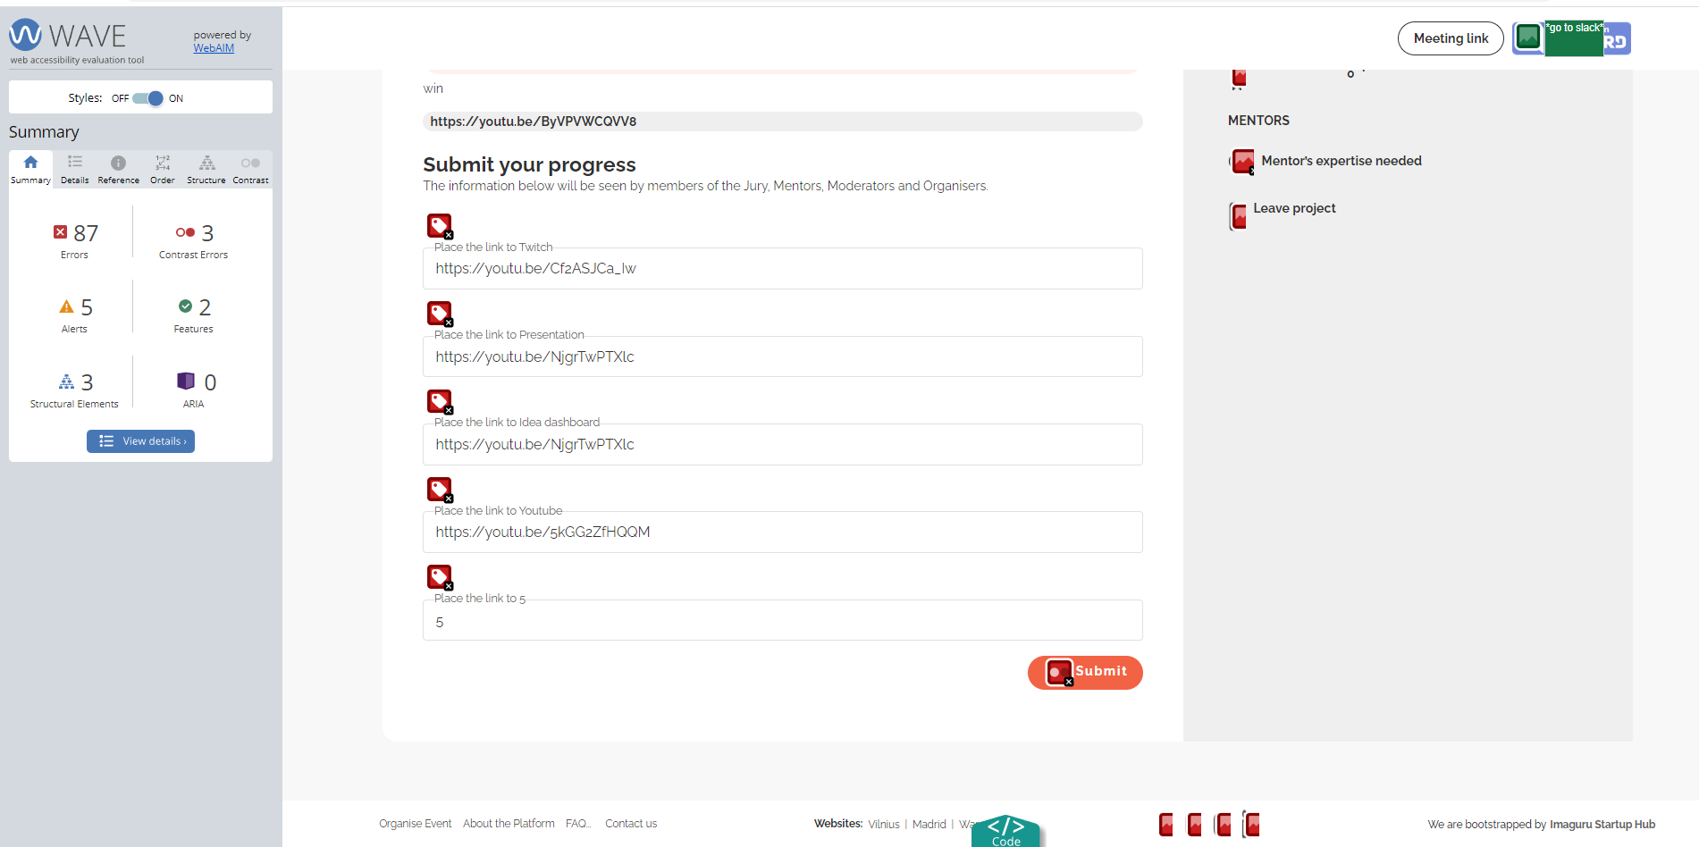

**Bug report 1**

**Summary:** Team’s member section in My project page has emptybuttons or buttons with no value text

**Severity:** Medium

**Note:** Test environment <https://imaguru.host/version-test>

**Precondition**: WAVE Evaluation Tool is installed and run. The user is Idea owner (IO)

**Steps to reproduce:**

1. Open <https://imaguru.host/version-test>

2. Log in with valid credentials

3. Click on hackathon from which IO created his project

4. Click My project tab

5. Check availability of empty buttons or buttons with no value text

**Actual result:** Emptybuttons or buttons with no value text are presented in My project page mostly in Team’s member section.

A <button> element is present that contains no text content (or alternative text), or an <input type="submit">, <input type="button">, or <input type="reset"> has an empty or missing value attribute.

**Expected result:** Descriptive text must be on buttons in My project page

**Explanation:** When navigating to a button, descriptive text must be presented to screen reader users to indicate the function of the button.

**Conformance implications:** All non-text content that is presented to the user should have a text alternative that serves the equivalent purpose ([1.1.1 Non-text Content (Level A)](https://webaim.org/standards/wcag/checklist#sc1.1.1) of WCAG 2.1 requirements).

The purpose of each link should be determined from the link text alone or from the link text together with its programmatically determined link context ([2.4.4 Link Purpose (In Context) (Level A)](https://webaim.org/standards/wcag/checklist#sc2.4.4) of WCAG 2.1 requirements).

**Suggested remedies:** Place text content within the <button> element or give the <input> element a value attribute.

**5.** **(опционально) Установите Screen reader NVDA.**

Используя screen reader протестируйте страницу.

Результат выполнения: 1-2 баг репорта (однотипные проблемы описываются в одном баг репорте).

**Bug report 2**

**Summary:** Right sidebar menu collapsed and Chat icon in My project page are not available for users having problems with visual perception using screen recorder

**Severity:** Medium

**Note:** Test environment <https://imaguru.host/version-test>

**Precondition**: Screen reader NVDA is installed and run. The user is Idea owner (IO)

**Steps to reproduce:**

1. Open <https://imaguru.host/version-test>

2. Log in with valid credentials

3. Click on hackathon from which IO created his project

4. Click My project tab

5. Check that right sidebar menu and Chat icon in My project can be navigated by screen recorder

**Actual result:** Right sidebar menu collapsed and Chat icon in My project page are not available for users having problems with visual perception using screen recorder.

**Expected result:** Right sidebar menu collapsed and Chat icon in My project page are not available for users having problems with visual perception using screen recorder

**Explanation:** When navigating to a button, descriptive text must be presented to screen reader users to indicate the function of the button.

**Conformance implications:** All non-text content that is presented to the user should have a text alternative that serves the equivalent purpose ([1.1.1 Non-text Content (Level A)](https://webaim.org/standards/wcag/checklist#sc1.1.1) of WCAG 2.1 requirements).

**Suggested remedies:** Add an alt attribute to the image. The attribute value should accurately and succinctly present the content and function of the image. If the content of the image is conveyed in the context or surroundings of the image, or if the image does not convey content or have a function, it should be given empty/null alternative text (alt="").